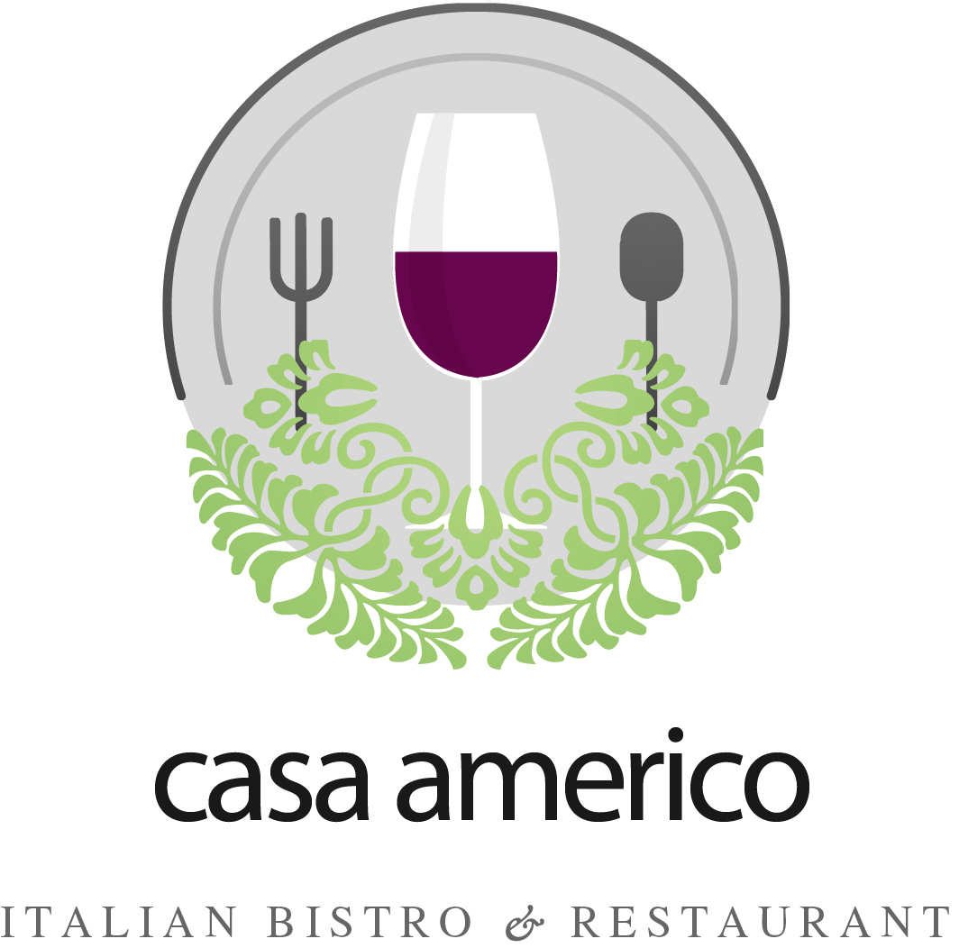
SET MENU # 1

Venue : Casa Americo – 144 Main Street East, Milton Tel: 289-878-4948 Fax:289-878-5311
E-mail : casaamerico@cogeco.net
Function Organizer: _____________________ Tel: ___-___-____ or ___-___-____
Function : ______________________________________________________
Total Guess : ______ Adults
Date : _______________ (Arrival Time _______ pm , Dinner Time: ________pm)

MENU
Bread and Butter

STARTER:
Soup or House Salad

ENTREE:
Choice of:
Chicken Supreme or Veal Scallopini with Mushroom Marsala sauce served with
Chef's choice of Vegetables + Roasted Mini Potatoes

DESSERT
Tiramisu

Coffee &Tea Included
Lattes, Cappuccino & Herbal Tea will be charged based on consumption

PRICE
$31.88 per Adult Plus Taxes and Gratuity
All Alcohol will be based on consumption

For Casa Americo For the Party

Signature Signature

SET MENU # 2

Venue : Casa Americo – 144 Main Street East, Milton Tel: 289-878-4948 Fax:289-878-5311
E-mail : casaamerico@cogeco.net
Function Organizer: _____________________ Tel: ___-___-____ or ___-___-____
Function : ______________________________________________________
Total Guess : ______ Adults
Date : _______________ (Arrival Time _______ pm , Dinner Time: ________pm)

MENU
Bread and Butter

APPETIZER:
Bruschetta with Goat Cheese

STARTER:
Soup or House Salad

ENTREE:
Choice of:
Chicken Supreme or Veal Scallopini with Mushroom Marsala sauce served with
Chef's choice of Vegetables + Roasted Mini Potatoes

DESSERT
Crème Brulee

Coffee &Tea Included
Lattes, Cappuccino & Herbal Tea will be charged based on consumption

PRICE
$37.88 per Adult Plus Taxes and Gratuity
All Alcohol drinks will be based on consumption

For Casa Americo For the Party

Signature Signature
SET MENU # 3
Venue : Casa Americo – 144 Main Street East, Milton Tel: 289-878-4948 Fax:289-878-5311
E-mail : casaamerico@cogeco.net
Function Organizer: _____________________ Tel: ___-___-____ or ___-___-____
Function : ______________________________________________________
Total Guess : ______ Adults
Date : _______________ (Arrival Time _______ pm , Dinner Time: ________pm)

MENU
Bread and Butter
APPETIZER:
Garlic Bread with Cheese & Risotto Fritters
STARTER:
Soup or House Salad

SECOND COURSE:
Penne Alla Vodka or Veg Pasta

ENTREE:
Choice of:
Chicken Supreme or Veal Scallopini with Mushroom Marsala sauce
or Salmon with Cherry Tomatoes served with
Chef's choice of Vegetables + Roasted Mini Potatoes

DESSERT
Choice of:
Tiramisu or Crème Brulee

Coffee &Tea Included
Lattes, Cappuccino & Herbal Tea will be charged based on consumption

PRICE
$44.88 per Adult Plus Taxes and Gratuity
All Alcohol will be based on consumption

For Casa Americo For the Party

Signature Signature

SET MENU # 4
Venue : Casa Americo – 144 Main Street East, Milton Tel: 289-878-4948 Fax:289-878-5311
E-mail : casaamerico@cogeco.net
Function Organizer: _____________________ Tel: ___-___-____ or ___-___-____
Function : ______________________________________________________
Total Guess : ______ Adults
Date : _______________ (Arrival Time _______ pm , Dinner Time: ________pm)

MENU
Bread and Butter

APPETIZER:
Risotto Fritters

STARTER:
Soup or House Salad

SECOND COURSE:
Penne Alla Vodka or Veg Pasta

ENTREE:
Choice of:
10 oz New York Steak with black trulfle sauce
or Parmesan Crusted Baked Halibut, butter & white wine served with
Chef's choice of Vegetables + Roasted Mini Potatoes

DESSERT
Choice of:
Crème Brulee or Tiramisu

Coffee &Tea Included
Lattes, Cappuccino & Herbal Tea will be charged based on consumption

PRICE
$52.00 per Adult Plus Taxes and Gratuity
All Alcohol will be based on consumption

For Casa Americo For the Party

Signature Signature

